**Lab Report**

1．Whois report results for three domains

1. **Apples.com**
2. **Whois result screenshot**

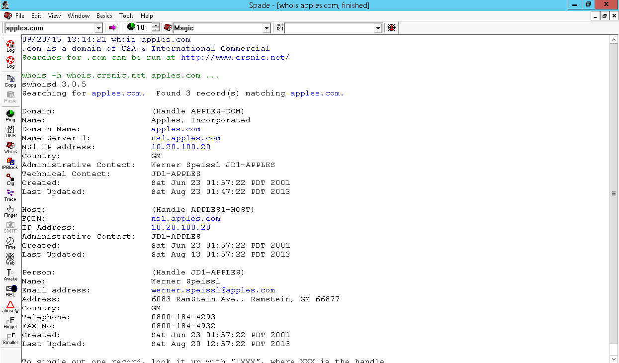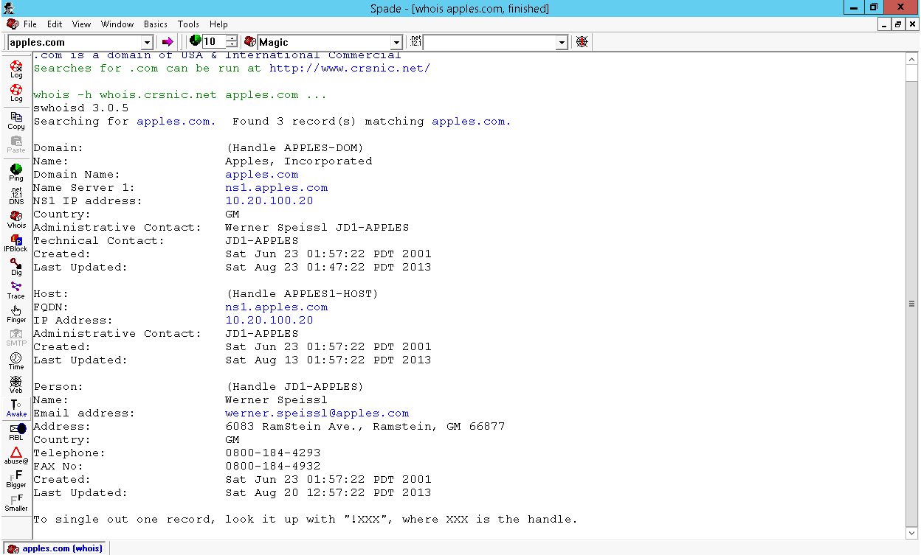

**Description:** it shows all critical information like hostname, organization name, possible location, created time, update time, domain user information, administrator and technical contact.

1. **Ping result screenshot**

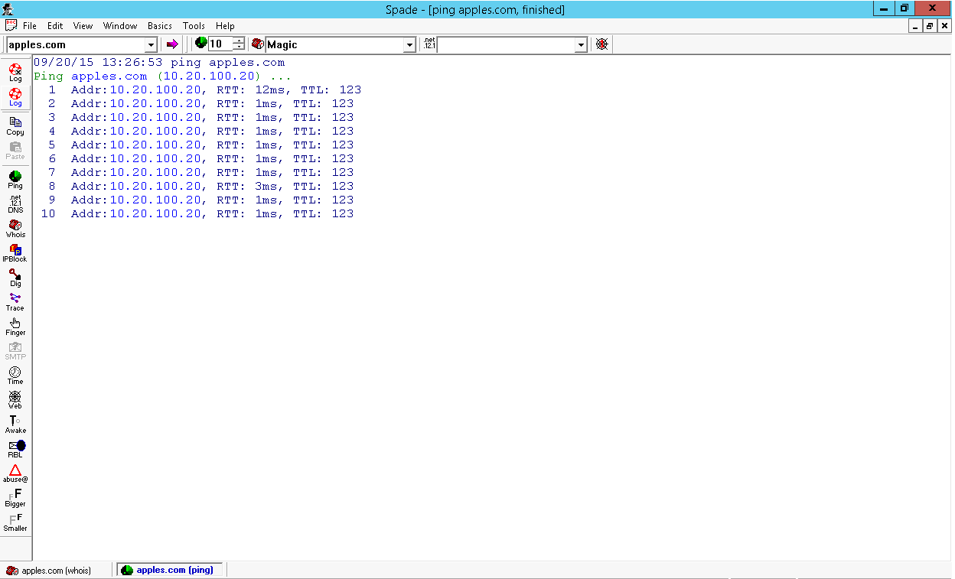

**Description:** use ping command to check whether target is alive or not.

1. **Nslookup result screenshot**

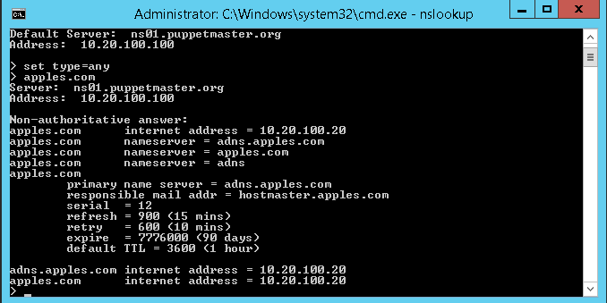

**Description:** it shows information about DNS server.

1. **Tracert results screenshot**

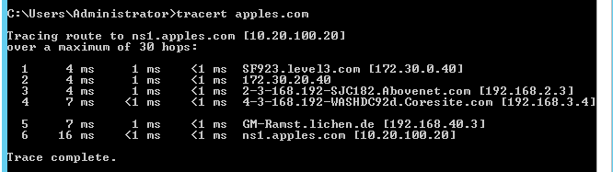

**Description:** it shows how many network nodes are there from Vworkstation desktop to apples.com and the detail things about each node.

1. **Oranges.com**
2. **Whois result screenshot**

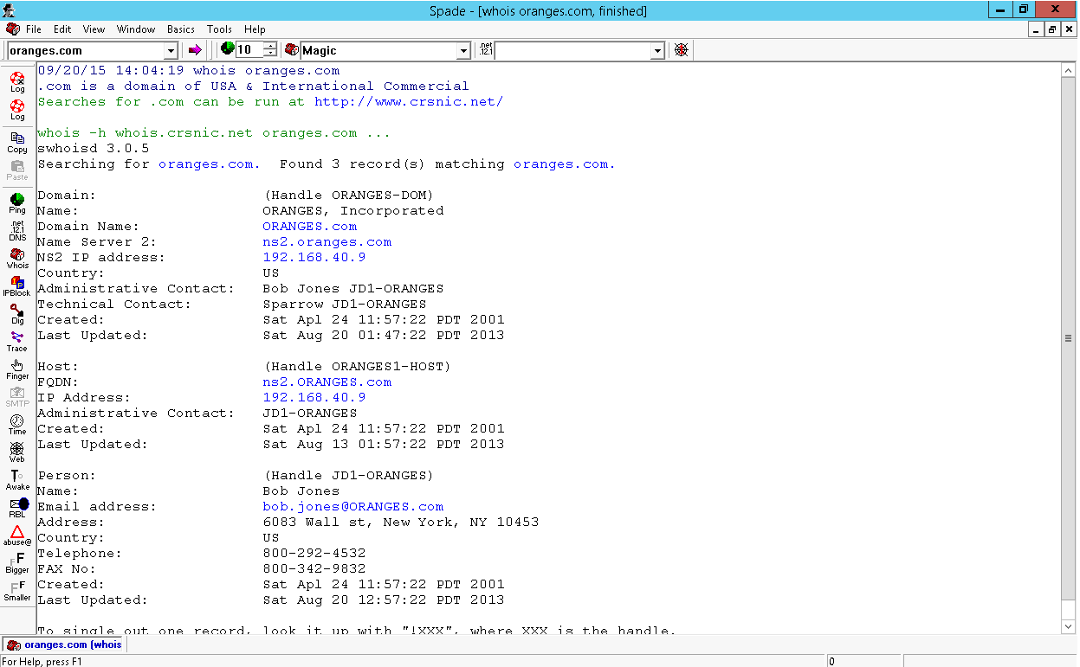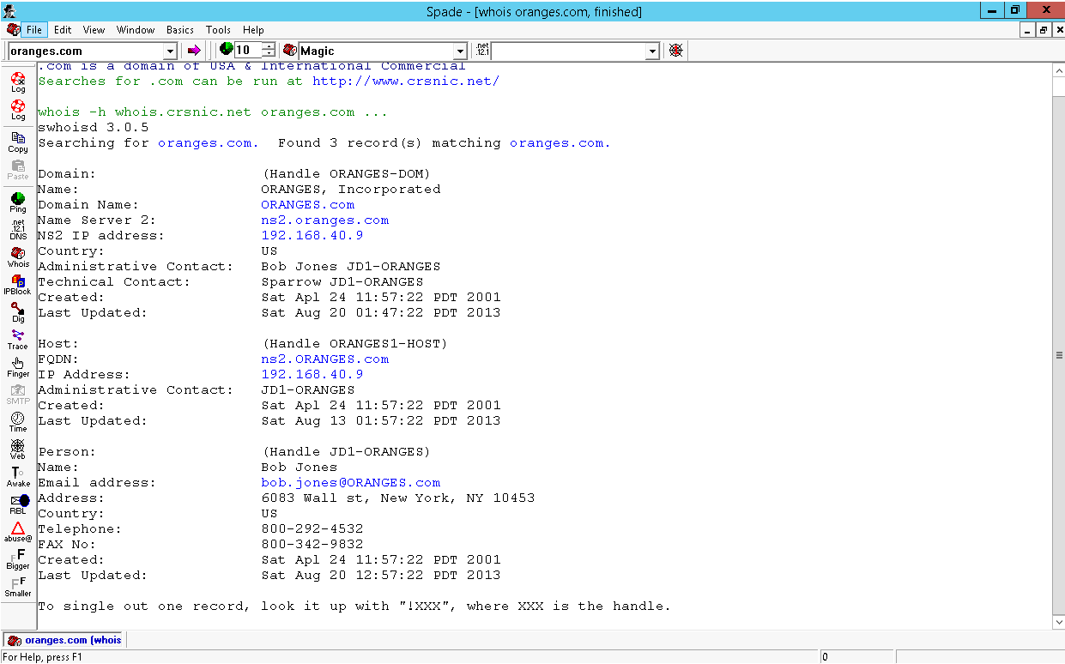

**Description:** it shows all critical information like hostname, organization name, possible location, created time, update time, domain user information, administrator and technical contact.

1. **Ping result screenshot**

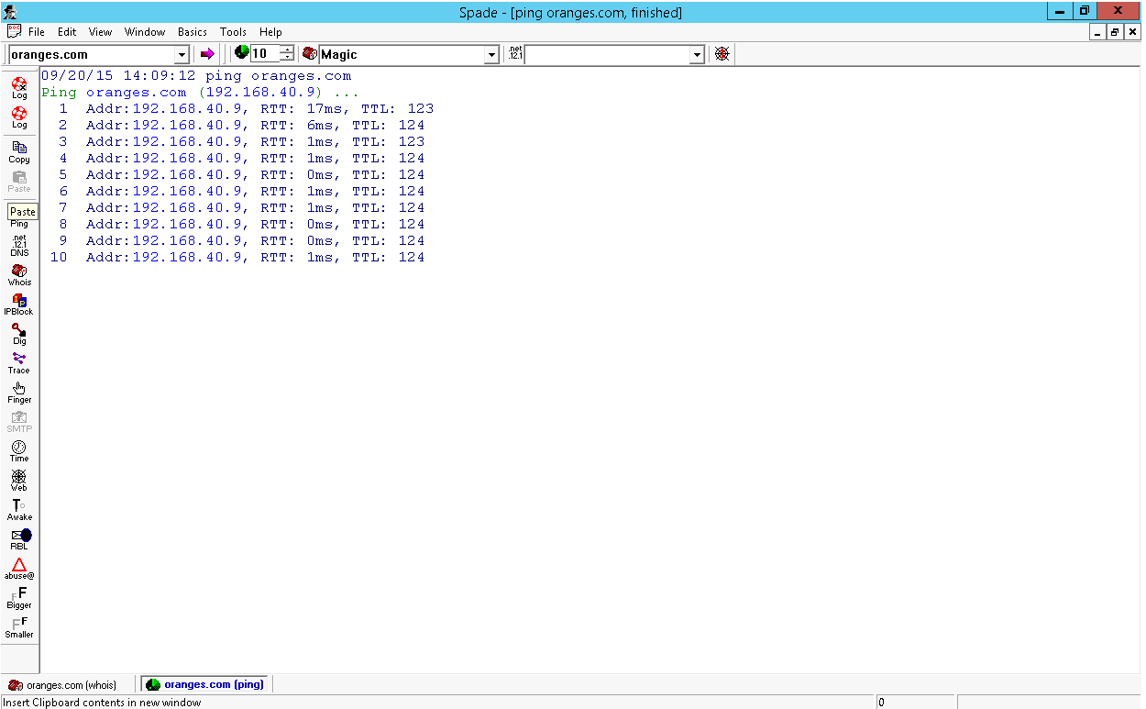

**Description:** use ping command to check whether target is alive or not.

1. **Nslookup result screenshot**

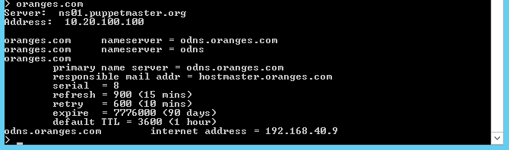

**Description:** it shows information about DNS server.

1. **Tracert results screenshot**

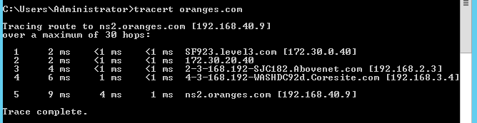

**Description:** it shows how many network nodes are there from Vworkstation desktop to apples.com and the detail things about each node.

1. **Bananas.com**
2. **Whois results screenshot**

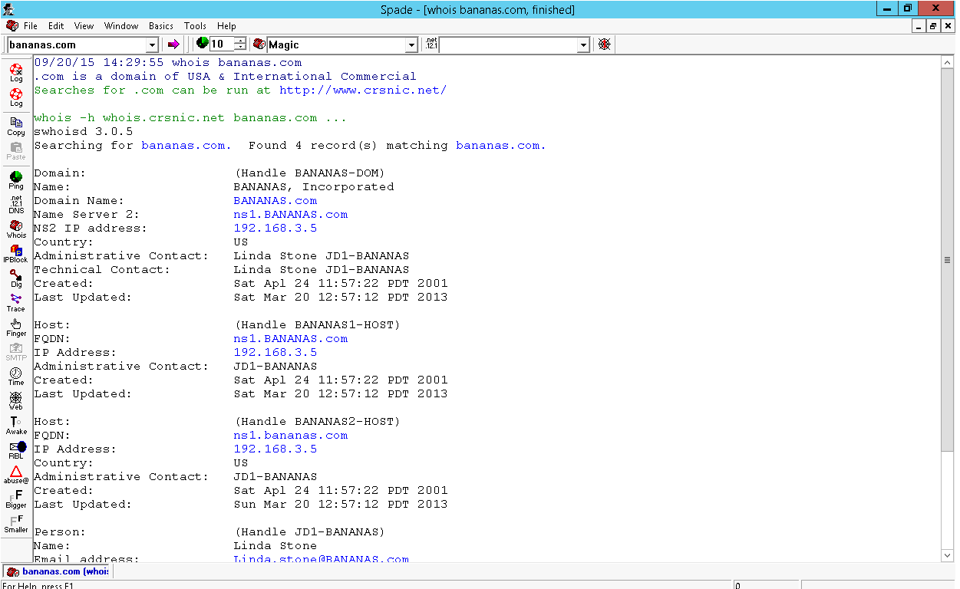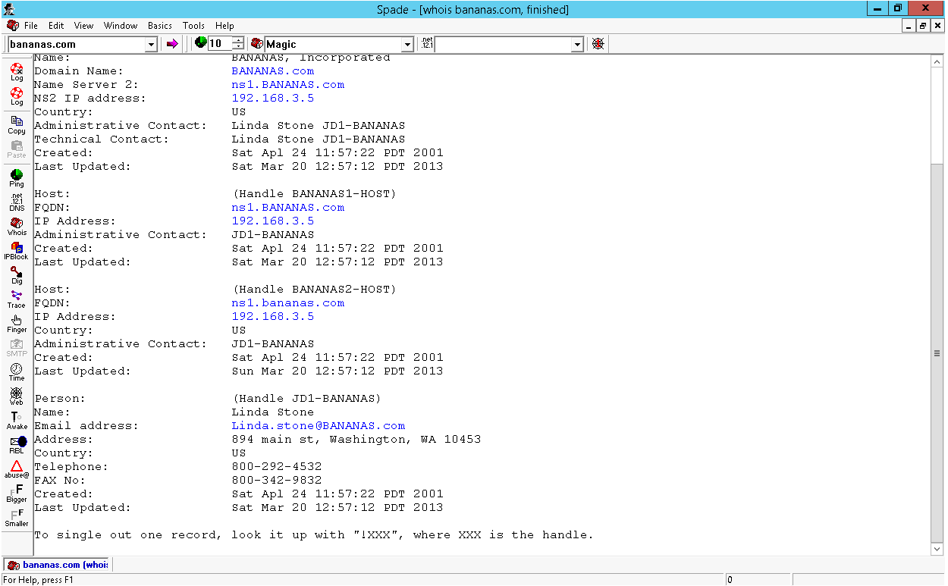

**Description:** it shows all critical information like hostname, organization name, possible location, created time, update time, domain user information, administrator and technical contact.

1. **Ping results screenshot**

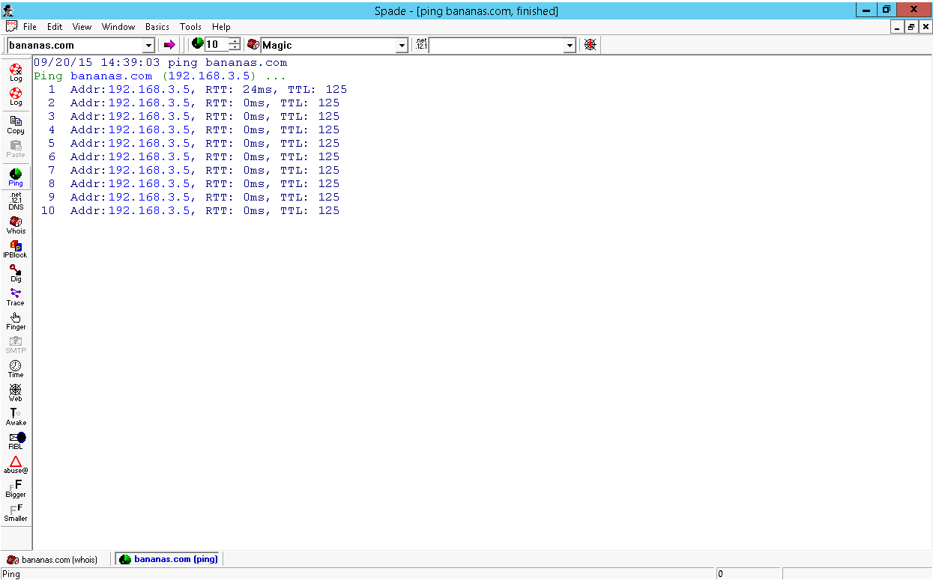

**Description:** use ping command to check whether target is alive or not.

1. **Nslookup results screenshot**

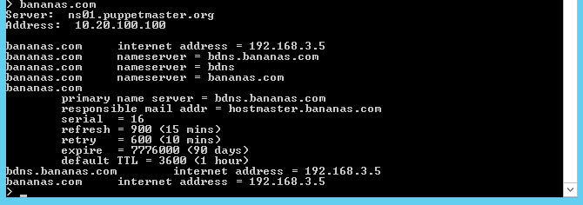

**Description:** it shows information about DNS server.

1. **Tracert results screenshot**

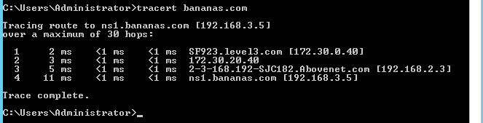

**Description:** it shows how many network nodes are there from Vworkstation desktop to apples.com and the detail things about each node.

1. **Tools in basic menu**

This part is used to descript each tool provided by Sam Spade in Basic menu, I just take Oranges.com as an example.

1. **Nslookup**

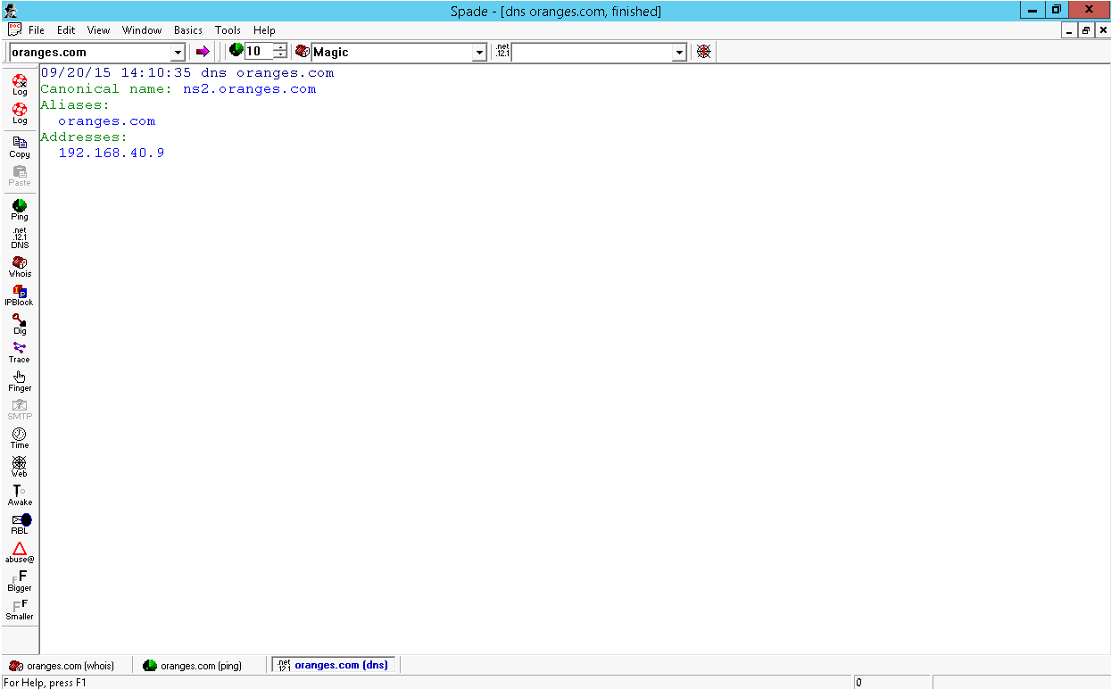

1. **IP Block**

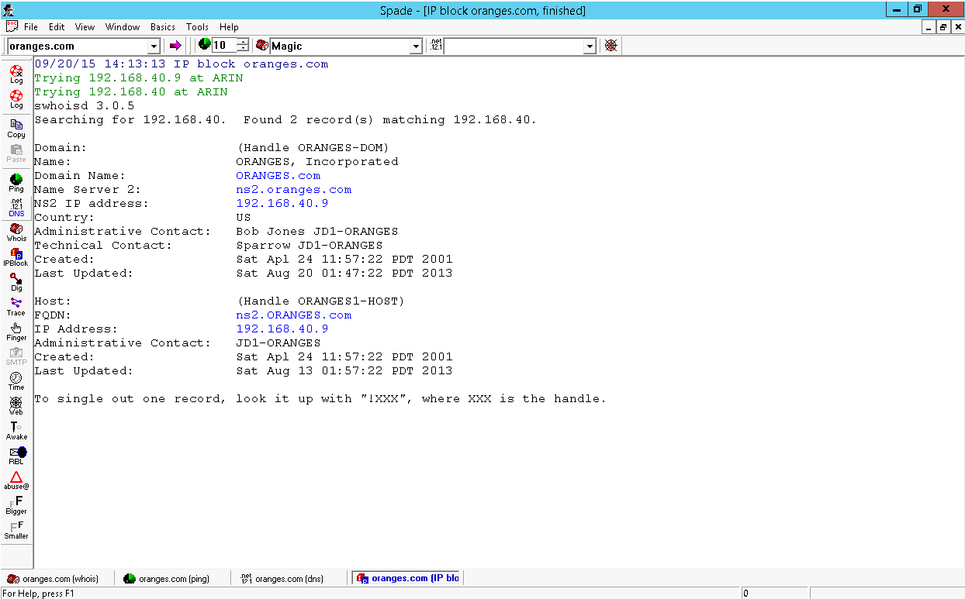

**Description:** determine the ownership and contact information for a block of IP addresses. It is useful to determine specific information about a host and determine upstream Internet Service provider

1. **Dig**

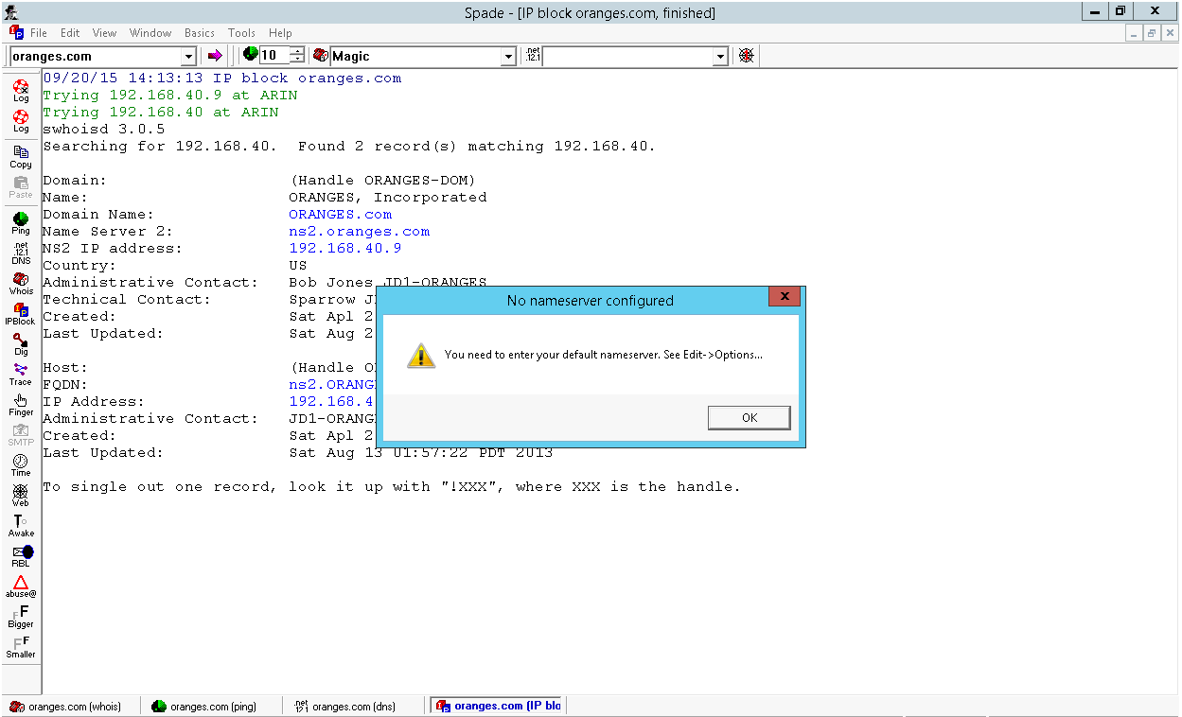

**Description:** an advanced DNS tool that returns all of the available Resource Records for a given domain or host.

1. **Traceroute**

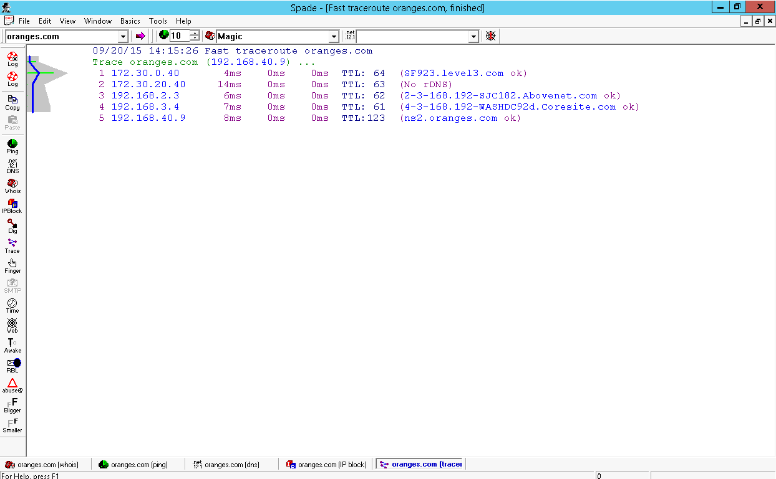

**Description:** the route packets may take to the host specified in the address bar. Good for determining the upstream providers of internet service, and for identifying delays.

1. **Finger**

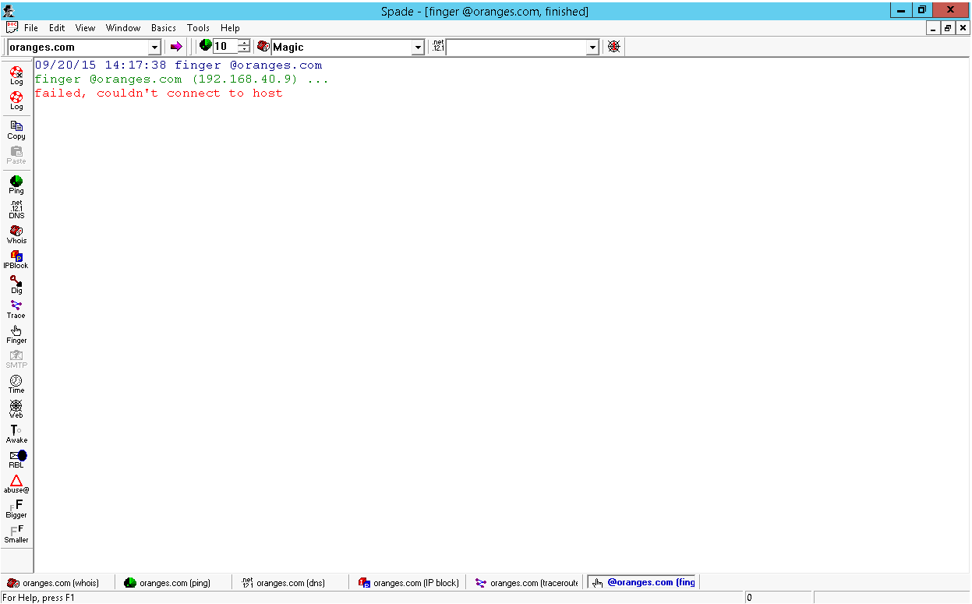

**Description:** obtains host/user information from a host running the finger daemon.

1. **SMTP Verify**

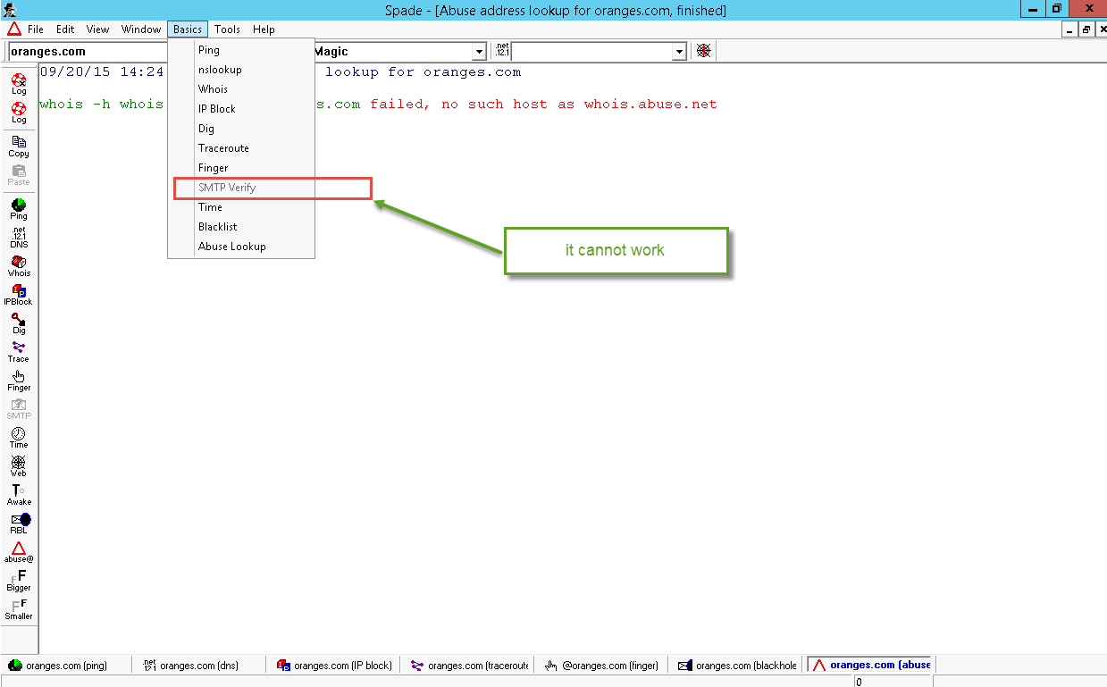

**Description:** Used to verify whether an email address is a true address or is being forwarded.

1. **Time**

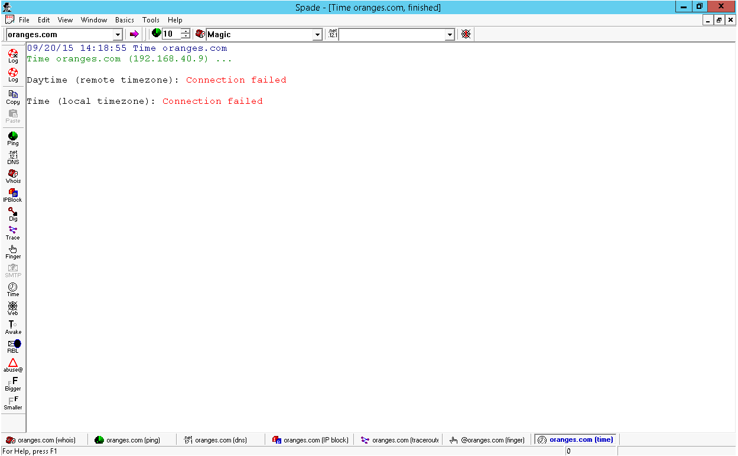

**Description:** return time from server

1. **Blacklist**

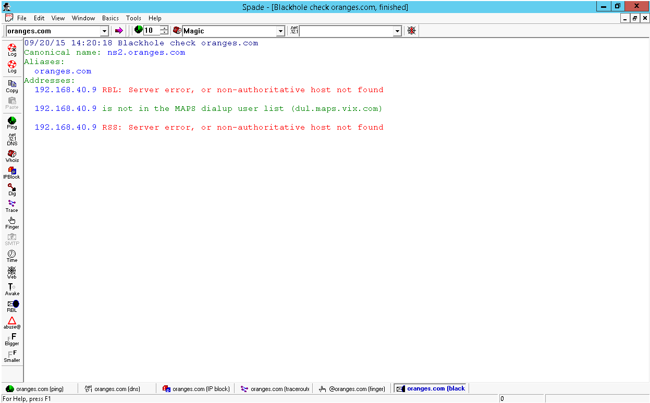

**Description:** allow user to check web sites that keep track of known spammers.

1. **Abuse Lookup**

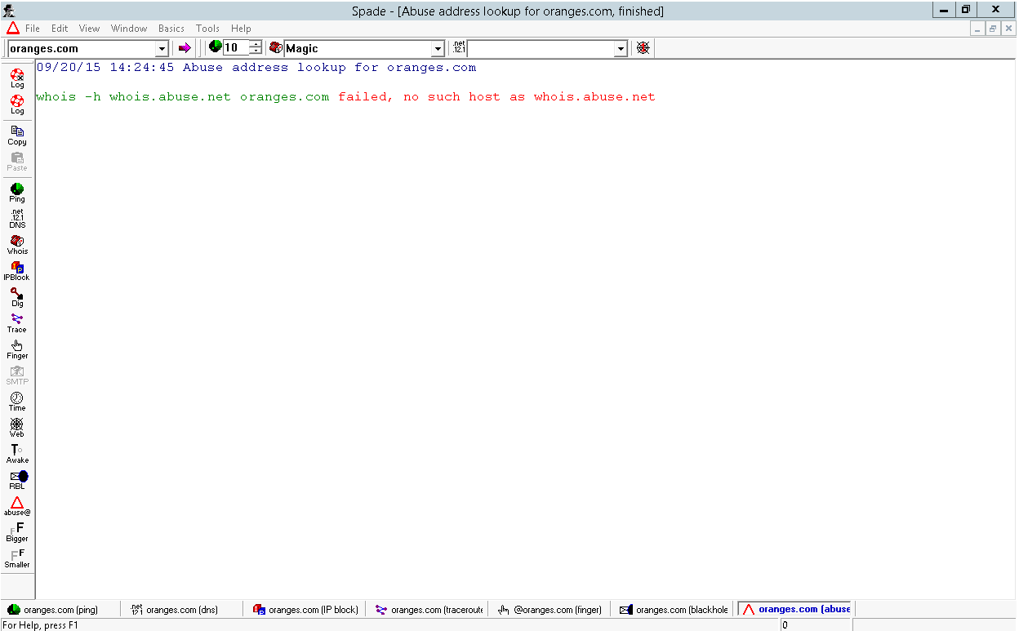

**Description:** allow user to check web sites that keep track of known spammers.

**References:**

Microsoft. (2009, 10 13). *Microsoft Security Bulletin MS09-050 - Critical*. Retrieved 9 21, 2005, from technet.microsoft.com: https://technet.microsoft.com/en-us/library/security/ms09-050

SANS Institute InfoSec. (2003). *Using Sam Spade.*